Ex.no:3 | DATA CLEANING

Aim:
To clean and preprocess the Chess Games Dataset by identifying and handling missing values, removing duplicate and blank game records, standardizing categorical values, correcting data types, and preparing a consistent and reliable dataset for further chess game analysis.

Algorithm:
Check Missing Values
- Start.
- Import the Pandas library.
- Load the Chess Games dataset into a DataFrame (df).
- Display dataset information using df.info().
- Check for missing values using df.isnull().
- Count missing values in each column using df.isnull().sum().
- Check missing values using df.isna().
- Check non-missing values using df.notnull().
- Display the missing-value results.

Drop Missing Values
- Start.
- Import the Pandas library.
- Load the Chess Games dataset into a DataFrame (df).
- Drop rows containing missing values using dropna().
- Use axis=0 to remove rows or axis=1 to remove columns.
- Use how='any' to remove rows or columns containing any missing value.
- Use how='all' to remove rows or columns only when all values are missing.
- Use thresh=N to retain rows or columns with at least N non-missing values.
- Use subset=['column_name'] to remove rows based on specific columns.
- Use inplace=True to modify the original DataFrame.
- Display the cleaned Chess Games dataset.

Program:

import pandas as pd

# Load Chess Games Dataset
df = pd.read_csv("games.csv")

print("\nOriginal Dataset:")
display(df.head())

# Dataset Information
print("\nDataset Information:")
df.info()

# Check Missing Values

print("\nMissing Values using isnull():")
display(df.isnull())

print("\nMissing Values Count:")
print(df.isnull().sum())

print("\nMissing Values using isna():")
display(df.isna())

print("\nMissing Values Count using isna():")
print(df.isna().sum())

print("\nNon-Missing Values:")
display(df.notnull())

print("\nTotal Missing Values:")
print(df.isnull().sum().sum())

# Remove Blank Rows and Duplicate Records

df = df.dropna(how="all")

df = df.drop_duplicates()

# Standardize Categorical Columns

df["rated"] = (
df["rated"]
.astype(str)
.str.strip()
.str.title()
)

df["victory_status"] = (
df["victory_status"]
.astype(str)
.str.strip()
.str.lower()
)

df["winner"] = (
df["winner"]
.astype(str)
.str.strip()
.str.title()
)

df["opening_eco"] = (
df["opening_eco"]
.astype(str)
.str.strip()
.str.upper()
)

df["opening_name"] = (
df["opening_name"]
.astype(str)
.str.strip()
)

# Correct Numerical Data Types

df["turns"] = pd.to_numeric(
df["turns"],
errors="coerce"
)

df["white_rating"] = pd.to_numeric(
df["white_rating"],
errors="coerce"
)

df["black_rating"] = pd.to_numeric(
df["black_rating"],
errors="coerce"
)

df["opening_ply"] = pd.to_numeric(
df["opening_ply"],
errors="coerce"
)

# Remove rows containing missing values

df = df.dropna()

# Missing Values After Cleaning

print("\nMissing Values After Cleaning:")
print(df.isnull().sum())

# Duplicate Records After Cleaning

print("\nDuplicate Records After Cleaning:")
print(df.duplicated().sum())

# Display Cleaned Dataset

print("\nCleaned Dataset:")
display(df.head())

# Cleaned Dataset Information

print("\nCleaned Dataset Information:")
df.info()

# Cleaned Dataset Shape
print("\nCleaned Dataset Shape:")
print(df.shape)
# Save Cleaned Dataset

df.to_csv(
"cleaned_games_dataset.csv",
index=False
)

print("\nCleaned chess games dataset saved successfully.").")

Output:
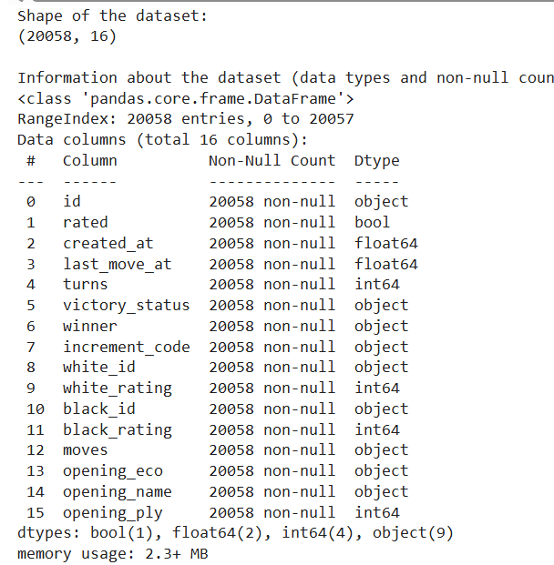

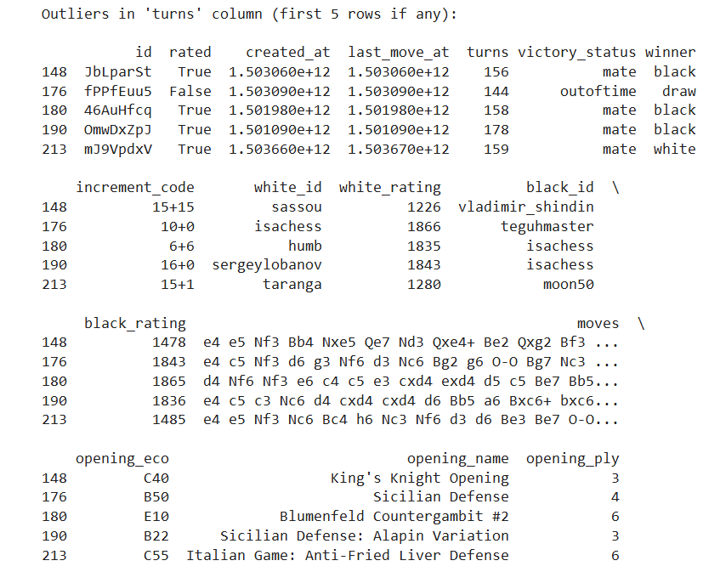
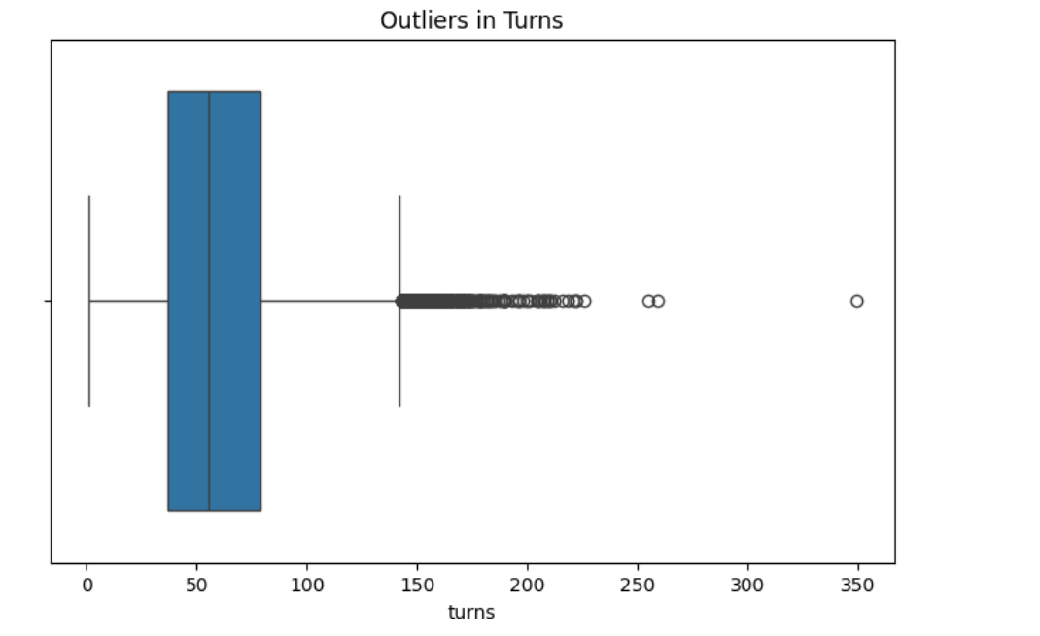

Result:

